Learning Cyber Security
DG Interns Hub | Week 1 | TryHackMe Room Writeup

Objective
Understand introductory cybersecurity concepts and learning pathways.

Activity summary
Worked through the room learning materials and completed the associated knowledge checks.

Key learning
Basic cyber roles, defensive and offensive security concepts.

Evidence
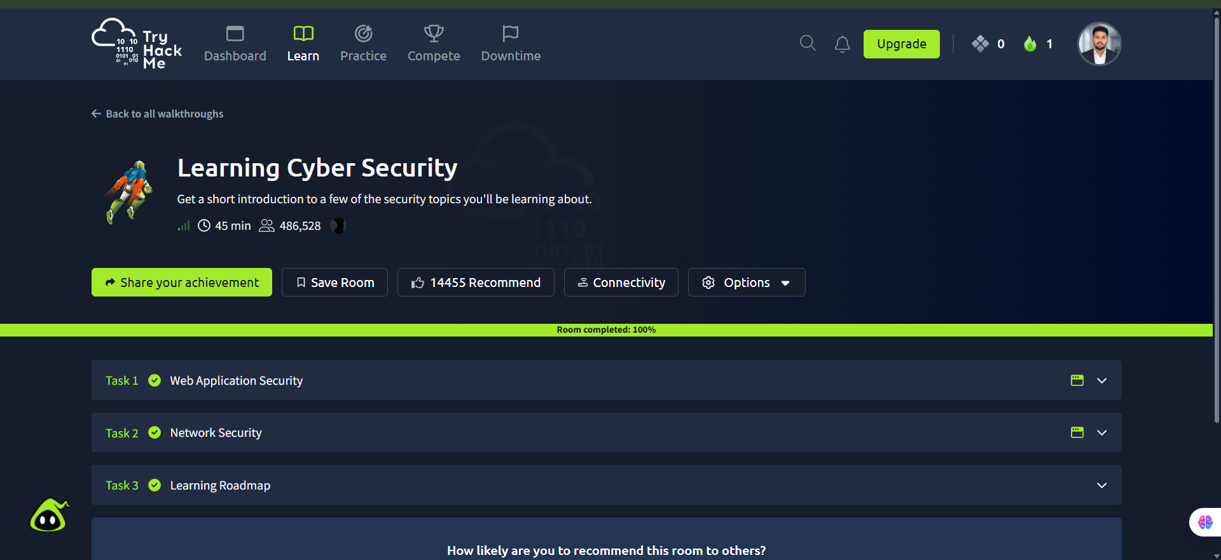
Screenshot: Learning_Cyber_Security.png
Completion screenshot provided; the original step-by-step room answers were not included in the archive.

